Neil Barot

Jacob Pinksa

Jared Pinksa

Anthony Ngo

Jalal Omer, Ph.D.

16 October 2022

Database Project Phase 2

**Business Rules and Integrity Constraints:**

CREATE TABLE Customer (

CID INT NOT NULL,

Name Varchar(30) NOT NULL,

Age INT NOT NULL,

Primary Key(CID),

CHECK (Age >= 18)

);

CREATE TABLE Schedule (

SID INT NOT NULL,

CID INT,

StartDate Varchar(10) NOT NULL,

EndDate Varchar(10) NOT NULL,

StartTime Varchar(6) NOT NULL,

EndTime Varchar(6) NOT NULL,

Primary Key(RID),

Foreign Key(CID) References Customer(CID),

ON DELETE cascade ON UPDATE cascade

CHECK(StartDate < EndDate OR (StartDate == EndDate AND StartTime <= EndTime))

);

CREATE TABLE Printer (

PID INT NOT NULL,

User INT,

FilamentAmt DOUBLE NOT NULL Default(0),

Filament varchar(30) NOT NULL Default(“PLA”),

Primary Key(PID)

Foreign Key(User) References Schedule (SID)

ON DELETE set NULL ON UPDATE cascade,

Foreign Key(FilamentType) References Supplier(Product)

ON DELETE set Default ON UPDATE cascade,

);

CREATE TABLE Supplier (

SID INT NOT NULL,

Product varchar(30) NOT NULL,

Price DOUBLE NOT NULL,

Primary Key(SID),

);

CREATE TABLE Employee (

EID INT NOT NULL,

Name varchar(30) NOT NULL,

RID INT,

SID INT,

Primary Key(EID),

Foreign Key(SID) References Supplier(SID),

ON DELETE set NULL ON UPDATE cascade

Foreign Key(RID) References Report(RID),

ON DELETE set NULL ON UPDATE cascade

);

CREATE TABLE Report (

RID INT NOT NULL,

SID INT NOT NULL,

Date Varchar(10) NOT NULL,

Usage DOUBLE NOT NULL,

Transaction INT

Primary Key(RID),

Foreign Key(SID) References Supplier(SID),

ON DELETE cascade ON UPDATE cascade

);

**Interface Requirements:**

* Simple, responsive interface with easy navigation.
* Users of the application have access to a dashboard that contains information about each 3D printer in the makerspace such as their availability, filament type, and filament amount.
* Users are first presented with a login screen where they would have to enter an ID to access the makerspace scheduler application.
  + If the user’s ID is for an employee, they have access to:
    - An additional menu that generates a report containing information about the report date, usage rate for each machine, and a delivery history for the transaction made in the makerspace.
    - An additional functionality on the dashboard, which is the ability to order filament to a particular 3D printer.
      * Once an employee selects a 3D printer to supply, they are presented with a form to order the product (filament type and amount) for a 3D printer.
      * Based on the filament type used by the 3D printer, the employee would have to order from a supplier that supplies that filament. Thus, the price and product differs from each supplier.
  + If the user’s ID is for a customer, they are presented with a menu containing a list of available 3D printers that they can reserve for use.
    - Once a customer selects an available 3D printer, they are presented with a list of available start/end dates and times for their appointment to choose from.
* Customers are not authorized to access functionality that employees can access such as ordering filament for a 3D printer. However, employees are authorized to access functionality that customers can access such as scheduling an appointment for a 3D printer.
* Logout functionality for customers and employees to exit the application.

**Database Schema:**

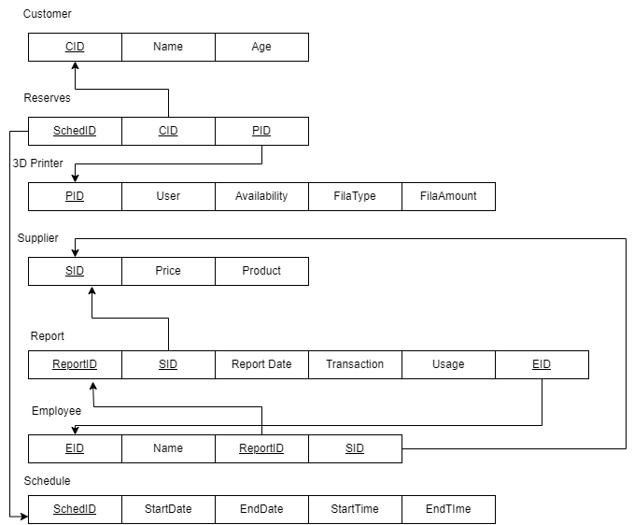

**ER Diagram:**

